Transform the data into normal distribution
The data is actually normally distributed, but it might need transformation to reveal its normality. For example, lognormal distribution becomes normal distribution after taking a log on it. The two plots below are plotted using the same data, just visualized in different x-axis scale. Observe how lognormal distribution looks normal when log is taken on the x-axis.

import numpy as np
import matplotlib.pyplot as plt
from scipy import stats
%matplotlib notebook

# sample data generation
np.random.seed(42)
data = sorted(stats.lognorm.rvs(s=0.5, loc=1, scale=1000, size=1000))

# fit lognormal distribution
shape, loc, scale = stats.lognorm.fit(data, loc=0)
pdf_lognorm = stats.lognorm.pdf(data, shape, loc, scale)
# visualize

fig, (ax1, ax2) = plt.subplots(1, 2, figsize=(8, 4))

ax1.hist(data, bins='auto', density=True)
ax1.plot(data, pdf_lognorm)
ax1.set_ylabel('probability')
ax1.set_title('Linear Scale')

ax2.hist(data, bins='auto', density=True)
ax2.plot(data, pdf_lognorm)
ax2.set_xscale('log')
ax2.set_title('Log Scale');

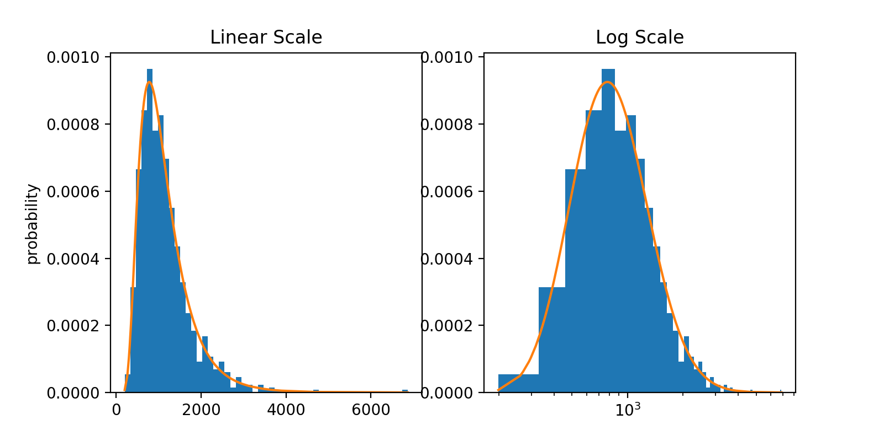
Similar transformations can be done on the sample data to convert non-normal to normal distribution. Lognormal transformation is used to convert rock permeability distributions to normal distribution, and square root transformation is used to analyze biological population growth, such as bacterial colonies per petri dish. These types of transformations - rescaling the distribution by taking exponents or log - are called Power Transformations. Box-Cox transformation is the most popular technique within the family of power transformations.

